# **Three-Tier Web Architecture on AWS**

## 1. Objective

To design and deploy a secure, scalable, and modular 3-tier architecture on AWS, separating the application logic, presentation, and database layers using EC2, RDS, S3, IAM, Load Balancers, and other AWS services.

## 2. Architecture Overview

### Tier 1: Presentation Layer (Web Tier)

* Hosted on EC2 instance
* Uses **Nginx** to serve the frontend application
* Publicly accessible
* Communicates with the internal load balancer to route requests to the App Tier

### Tier 2: Application Layer (App Tier)

* Backend logic using **Node.js**
* Deployed on private EC2 instance
* Managed using **PM2** for process handling
* Communicates with the database securely

### Tier 3: Data Layer (Database Tier)

* **MySQL RDS instance** hosted in private subnets
* No public access for enhanced security

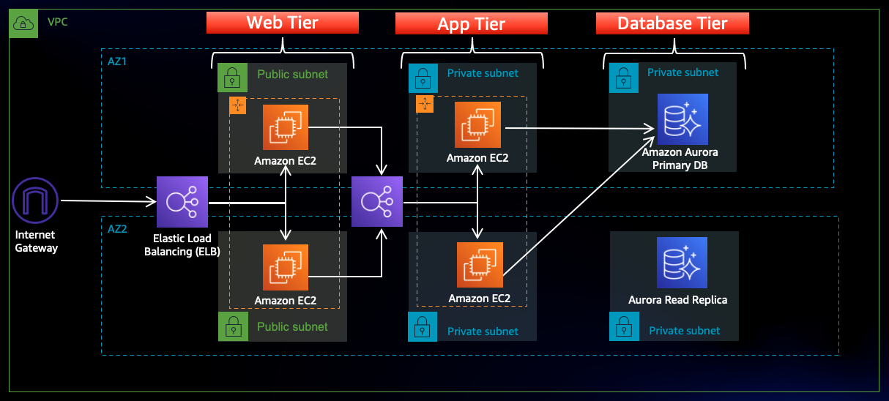

## 3. AWS Services Used

| **Service** | **Purpose** |
| --- | --- |
| VPC | Isolated network space |
| Subnets | Logical separation of resources (public & private) |
| EC2 | Hosts Web Tier and App Tier applications |
| RDS | Managed MySQL database for Data Tier |
| S3 | Stores source code, configs (nginx, dbconfig.js) |
| IAM | Secure permission control |
| Load Balancers | Distribute traffic between App/Web tiers |
| Target Groups | Attach EC2s to Load Balancers |
| Security Groups | Control traffic flow |
| Session Manager | Secure EC2 connection without SSH |

## 4. Step-by-Step Implementation

### Step 1: VPC and Subnet Setup

* Create custom VPC
* Add Public & Private Subnets in different Availability Zones

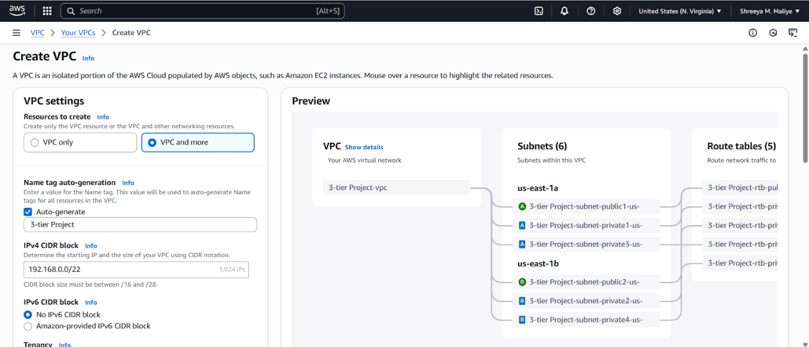

 Resource map diagram

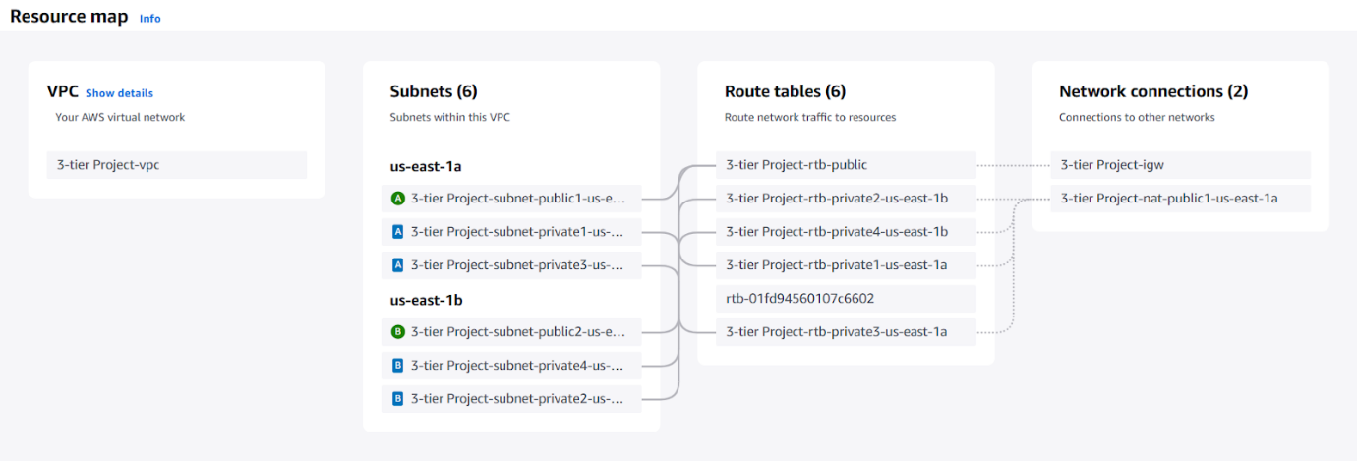

### Step 2: Create Security Groups

Create the following:

* Security Group for External Load Balancer

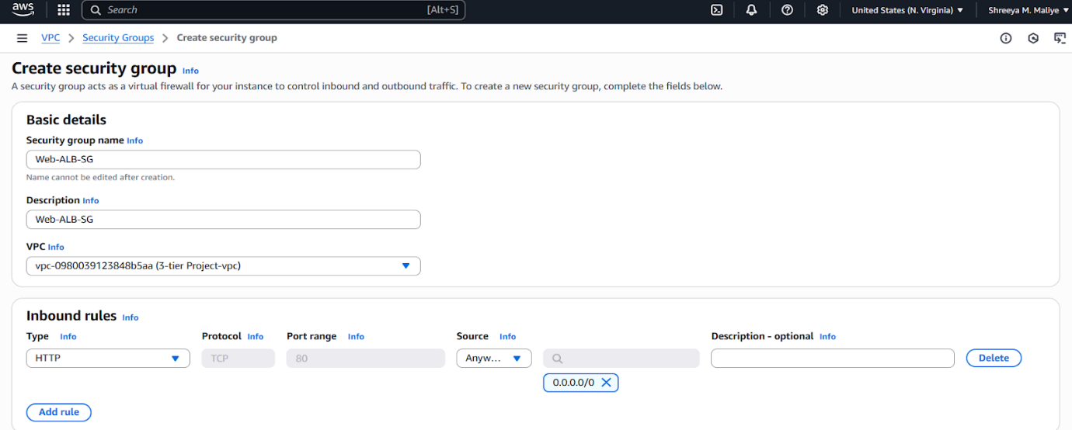

* Web Tier Security Group

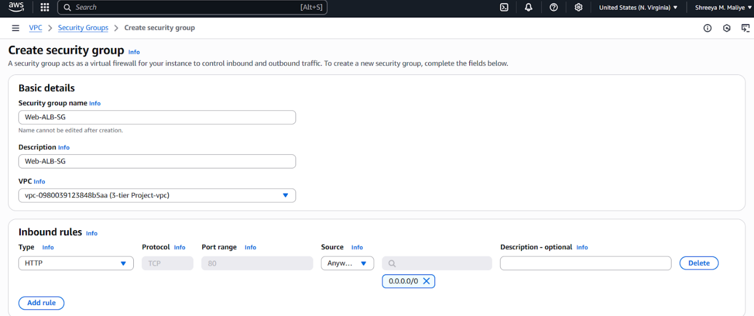

* App Tier Security Group

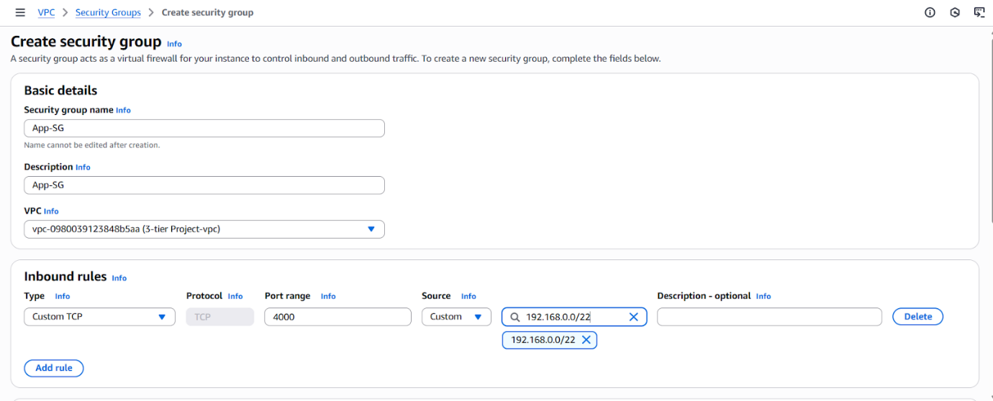

* Internal Load Balancer Security Group

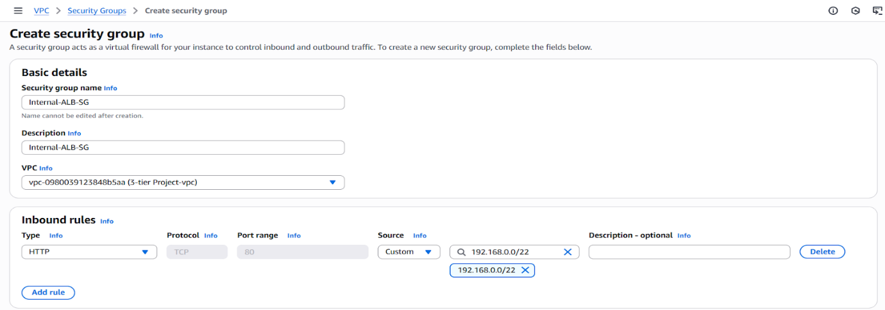

* Database Security Group

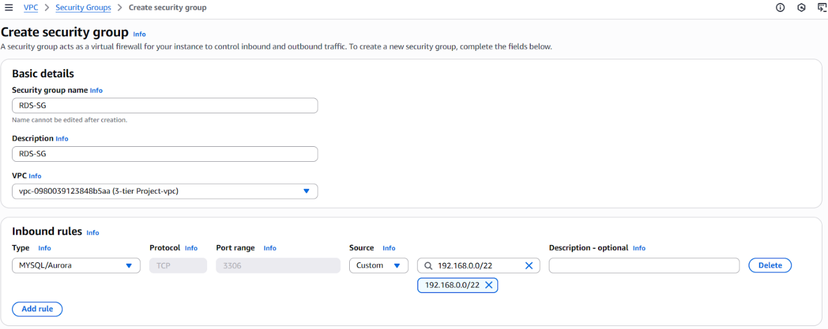

### Step 3: Prepare Source Code & Upload to S3

* Clone the GitHub repo locally

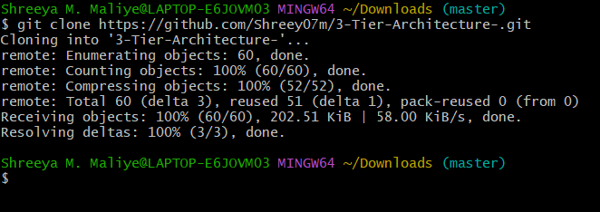

* Create S3 bucket and upload application files and nginx.conf

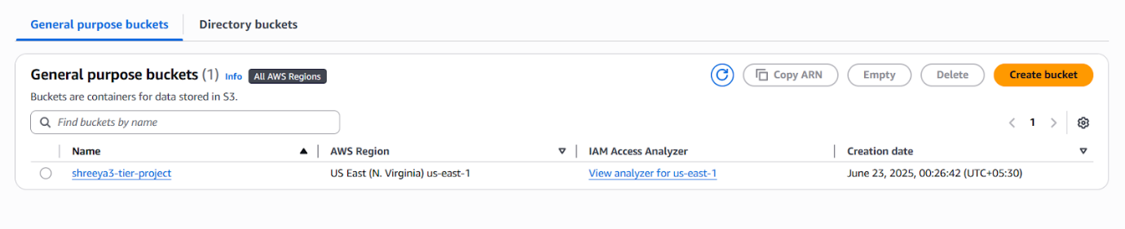

### Step 4: IAM Role

* Create IAM role with EC2 instance to call AWS services
* Attach to EC2 instances (App and Web tiers)

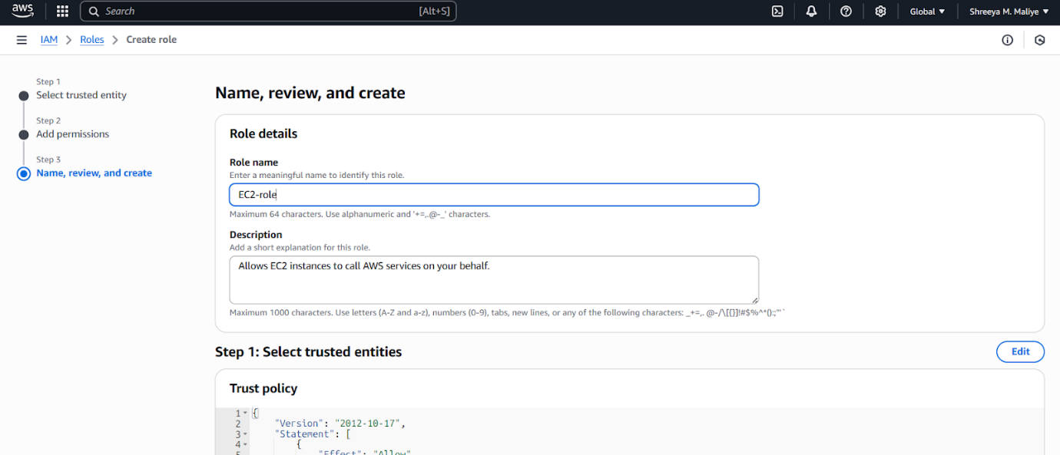

### Step 5: Launch RDS (MySQL)

* Create a DB Subnet Group

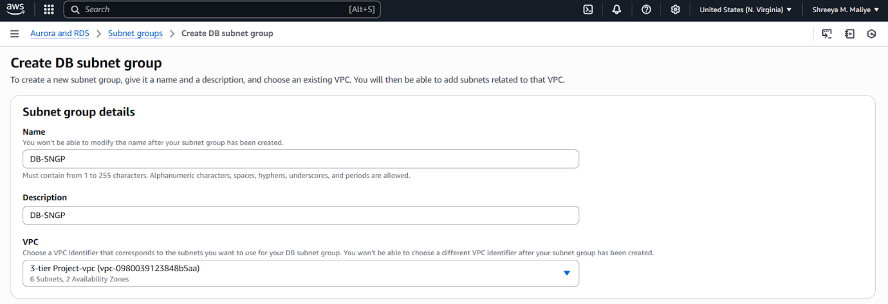

* Use private subnets for RDS

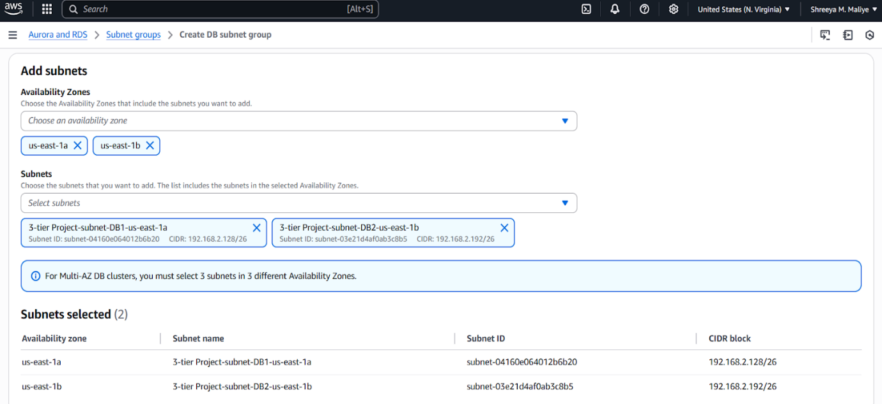

* Setup of RDS Database

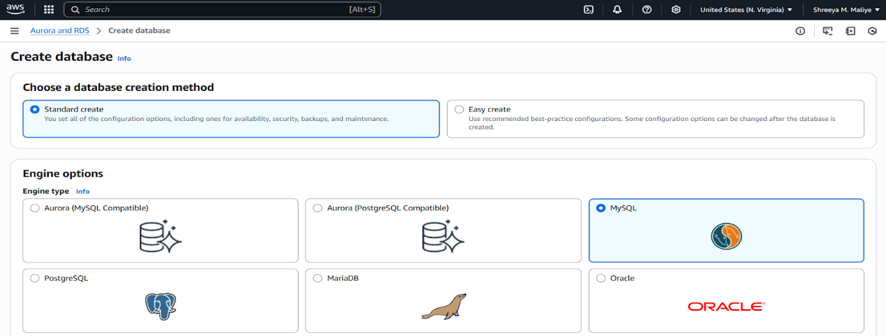

* + DB Name: three-tierdb
  + Master User: admin
  + Password: *******

### Step 6: Launch App Tier EC2 & Connect

* Launch EC2 instance in private subnet

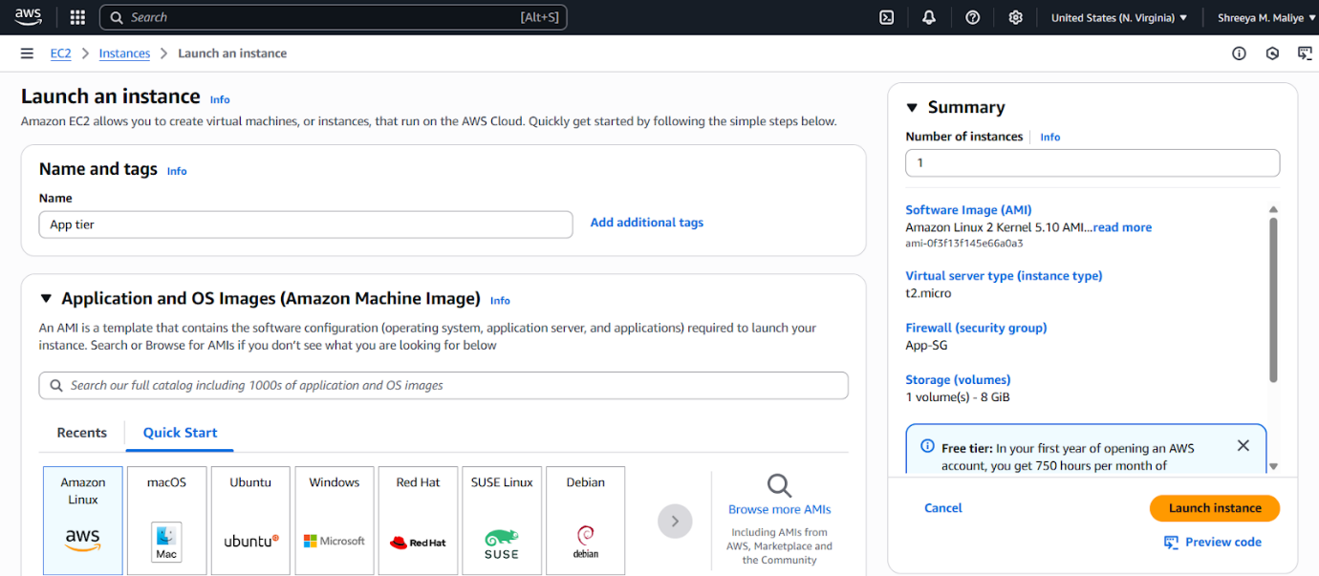

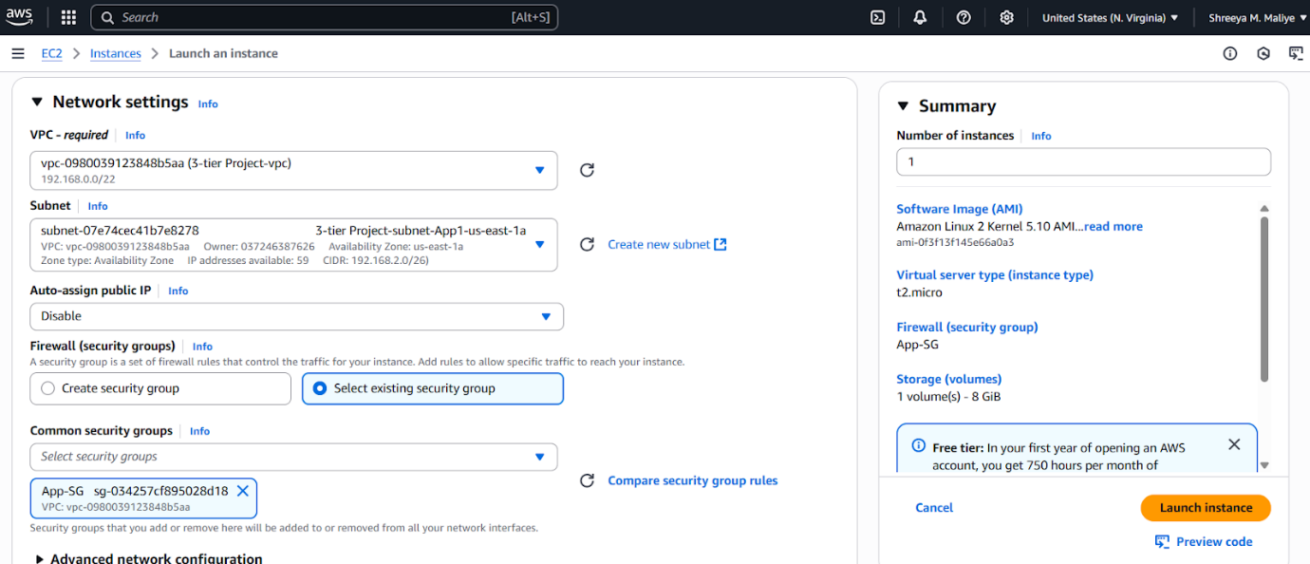

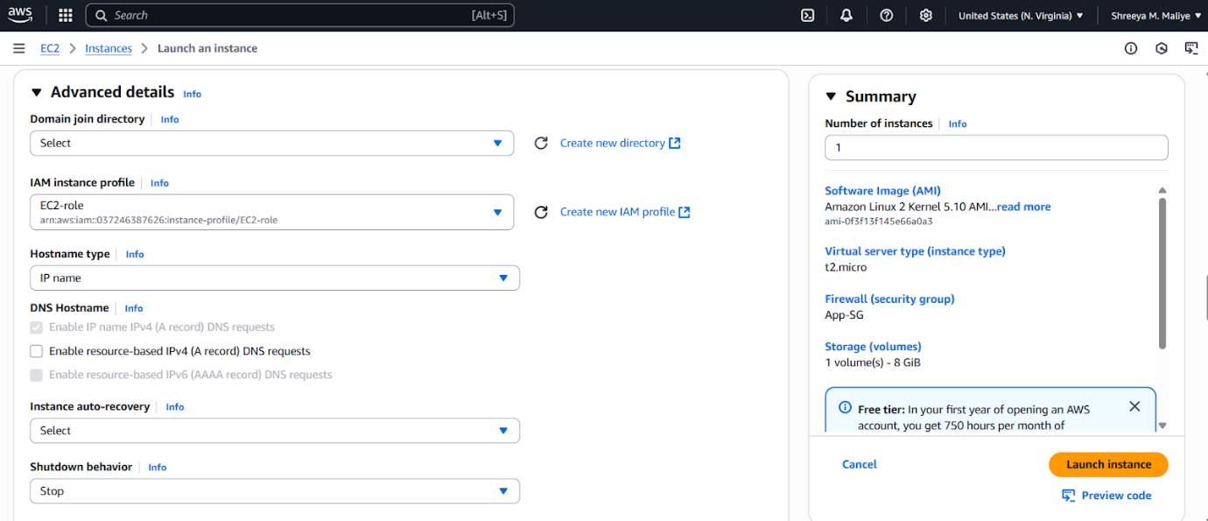

* Connect EC2 using **Session Manager**

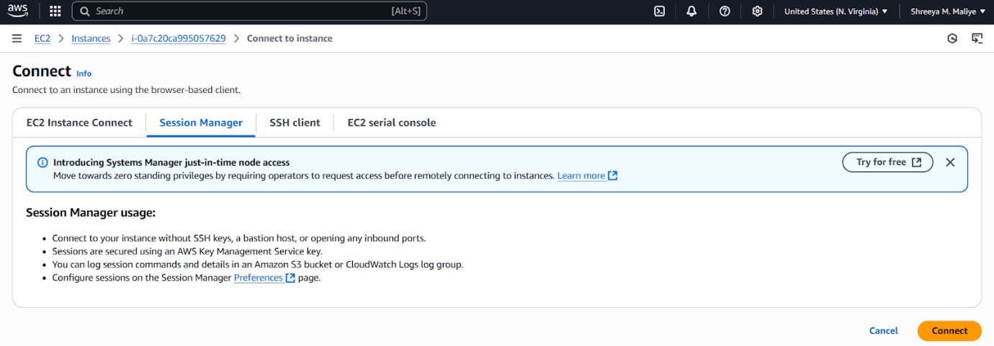

* Install MySQL client: sudo yum install mysql -y



* Connect to DB: mysql -h <DB Endpoint> -u admin -p

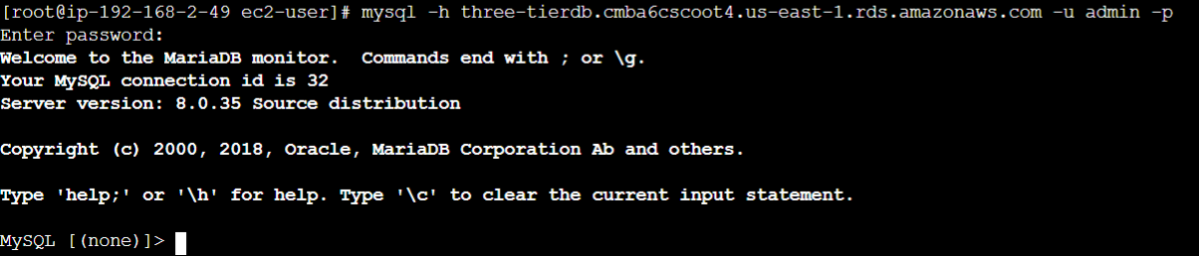

* Create Database:

CREATE DATABASE webappdb;  
USE webappdb;  
CREATE TABLE transactions (  
 id INT NOT NULL AUTO_INCREMENT,  
 amount DECIMAL(10,2),  
 description VARCHAR(100),  
 PRIMARY KEY(id)  
);

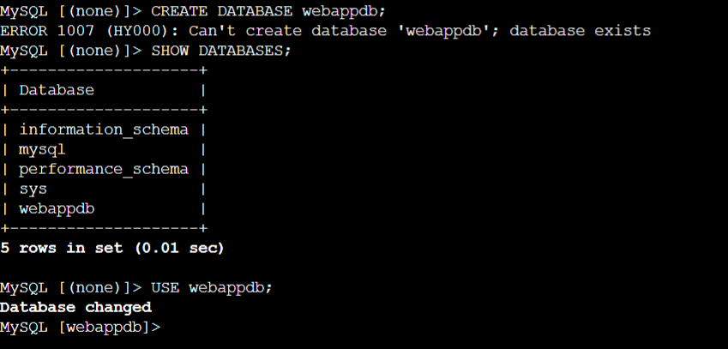

Insert information into the table and verify the entry is created or not

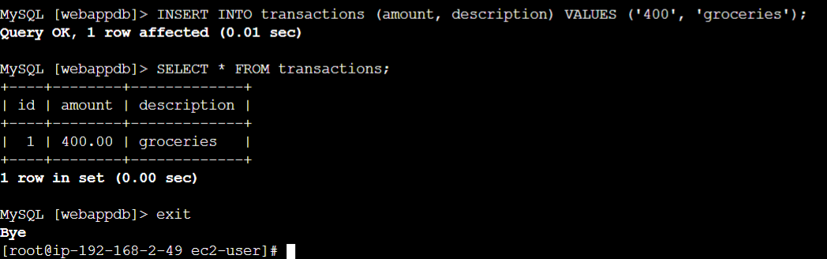

Change the [DbConfig.js](http://dbconfig.js)

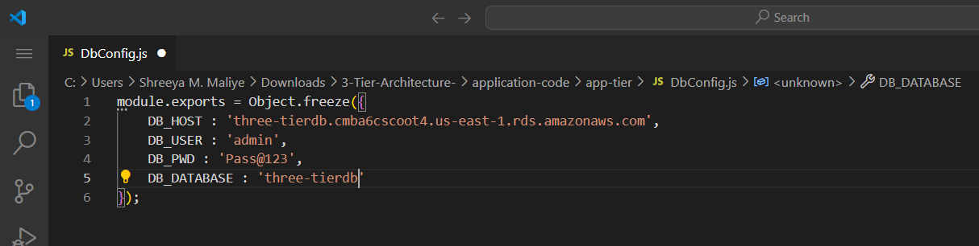

Update the [Dbconfig.js](http://dbconfig.js) file into S3 bucket

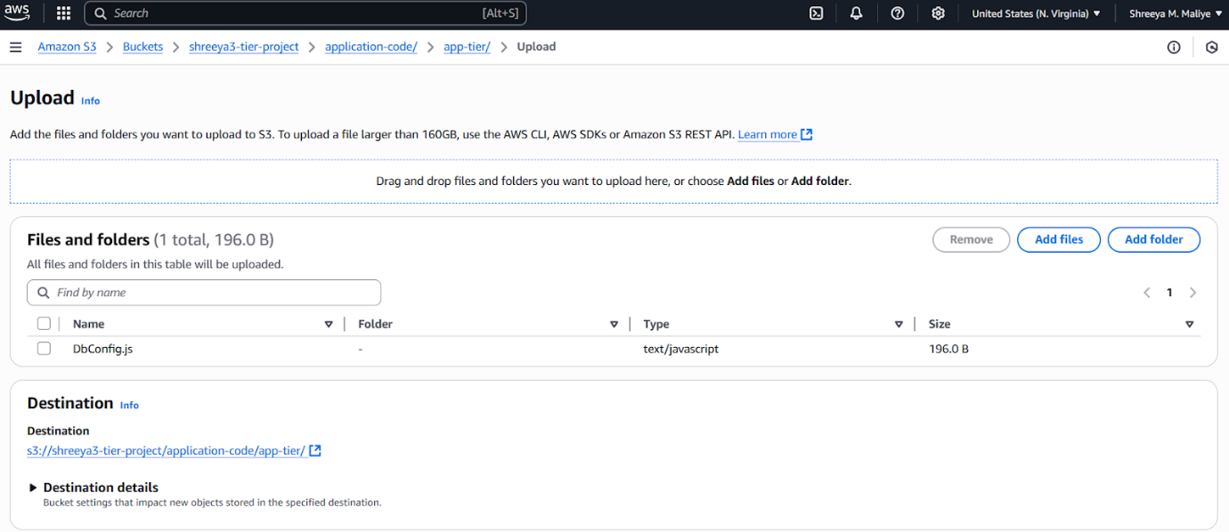

* Install Node.js and PM2:

nvm install 16  
npm install -g pm2

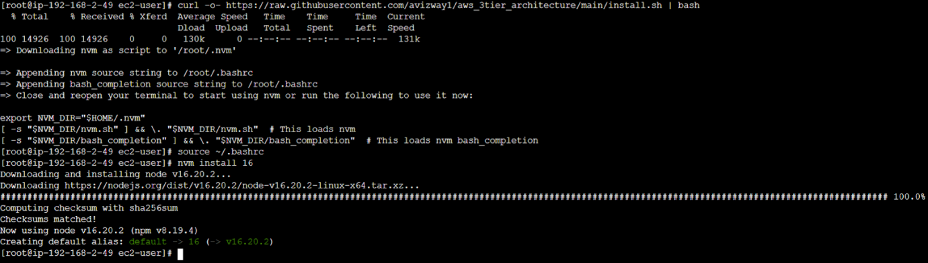

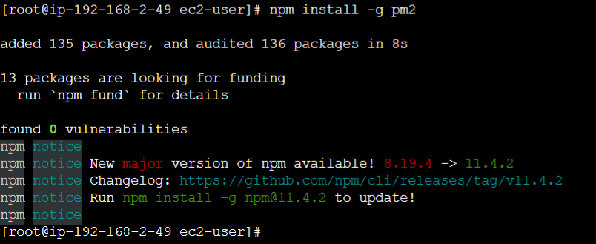

* Copy backend code from S3:

aws s3 cp s3://<bucket-name>/application-code/app-tier/ app-tier –recursive

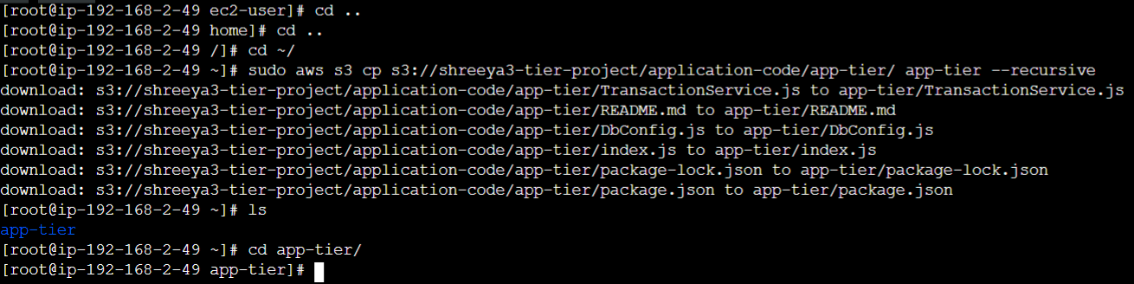

* Run app using pm2:

cd app-tier  
npm install  
pm2 start index.js  
pm2 save

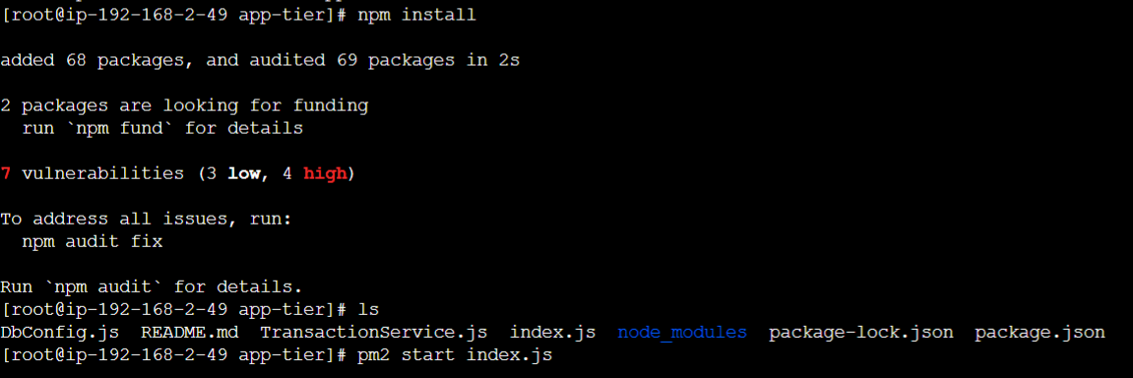

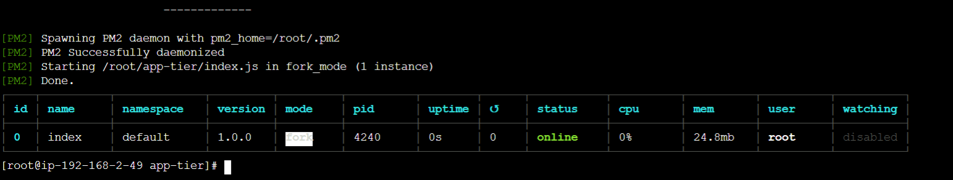

To verify: pm2 status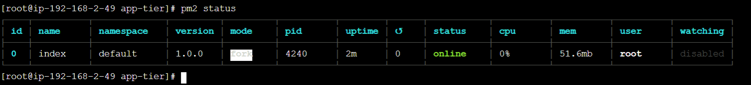

To check the logs: pm2 logs

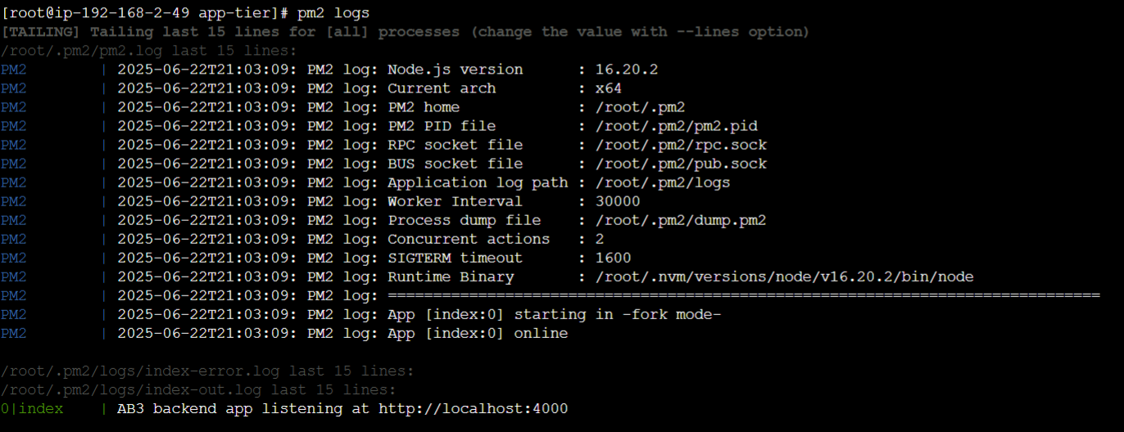

To start the pm2: pm2 startup

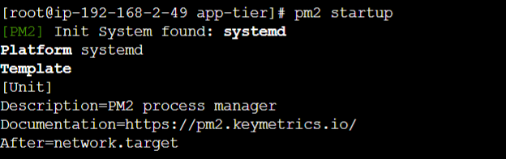

To save the pm2: pm2 save

Verify that the application is running by executing

curl <http://localhost:4000/health>

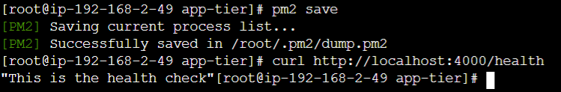

### 

### Step 7: Create Internal Load Balancer

Create one internal load balancer, before creating the load balancer we have to create target Group and attach the target group to load balancer

* Create Target Group on port 4000

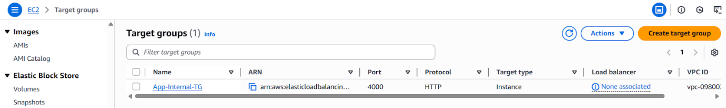

* Attach App Tier EC2 instance
* Create Internal Load Balancer and attach Target Group

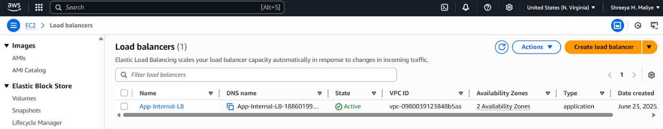

Copy the DNS name of the internal Load balancer and add it into the code of nginx.conf and upload the updated file into the S3 bucket

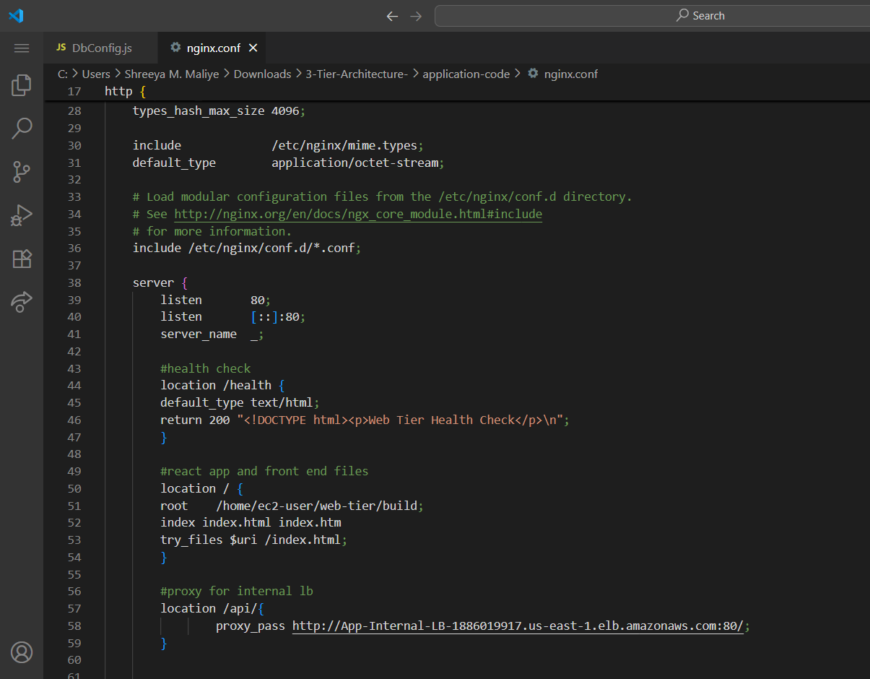

Successfully created the App tier resources !!!

### Step 8: Web Tier EC2 Setup

* Launch EC2 in public subnet

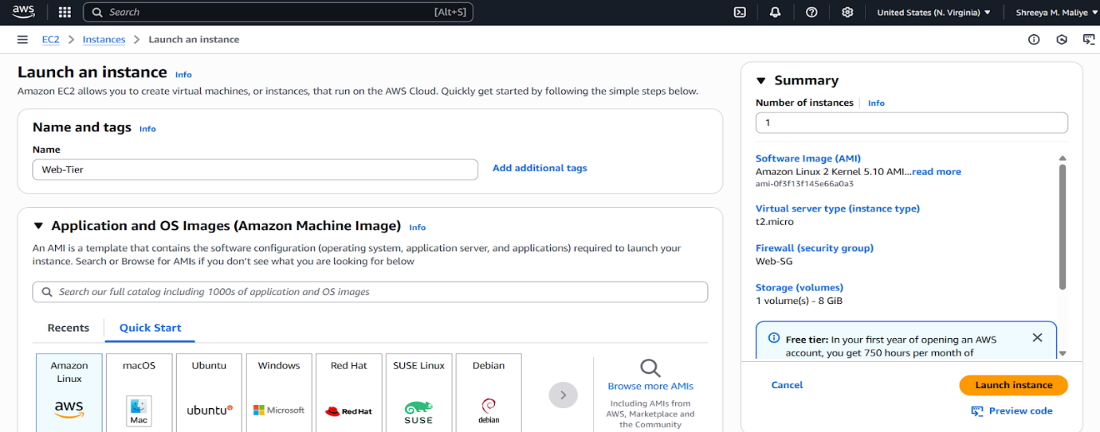

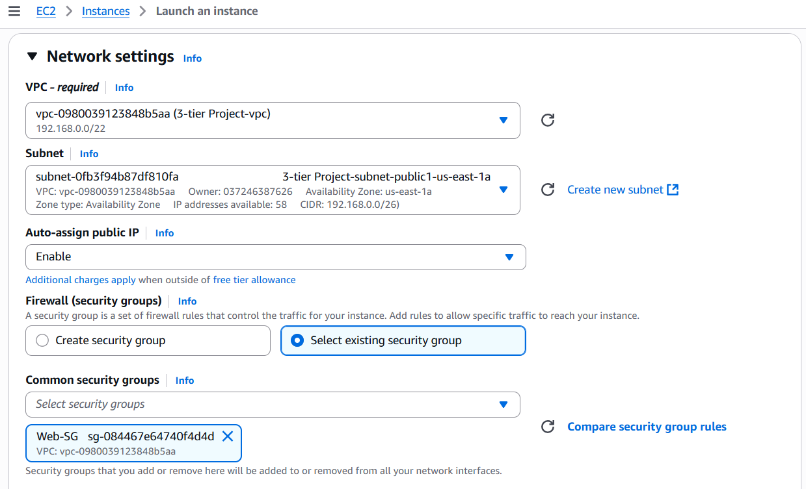

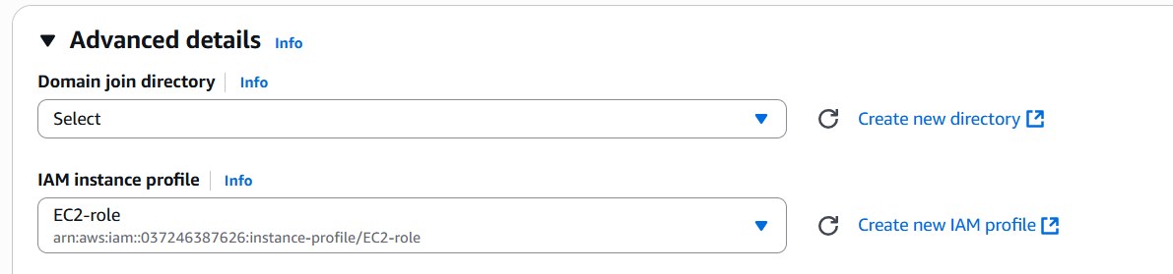

* Connect via EC2 Connect or Session Manager

sudo -su ec2-user (To work as an ec2-user)

cd /home/ec2-user

* Install Node.js & nginx

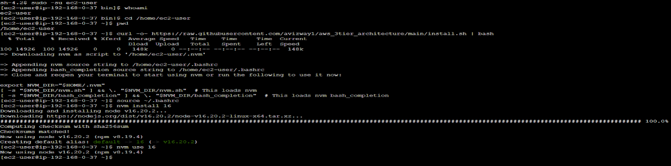

To install nginx server: sudo amazon-linux-extras install nginx1 -y

* Pull frontend code:

aws s3 cp s3://<bucket-name>/application-code/web-tier/ web-tier --recursive  
cd web-tier  
npm install  
npm run build

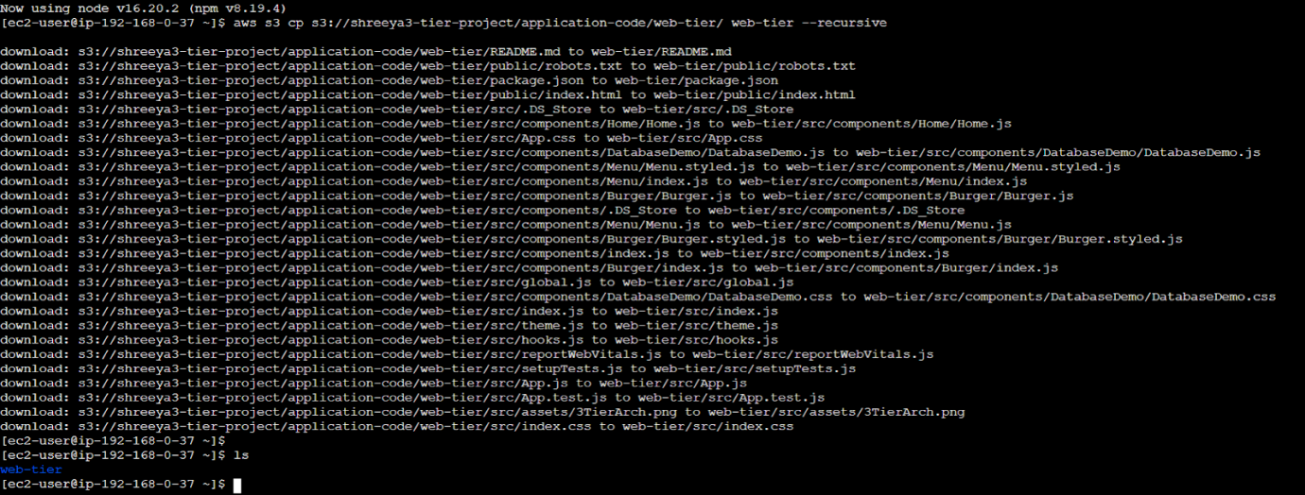

* Configure nginx:

cd /etc/nginx

ls



**Remove the nginx file:** sudo rm nginx.conf

**Upload the nginx file from the S3 bucket**

sudo aws s3 cp s3://<bucket-name>/application-code/nginx.conf .



Restart the nginx server, give the permission to it a and turn on the nginx server  
sudo service nginx restart  
chmod -R 755 /home/ec2-user  
sudo chkconfig nginx on

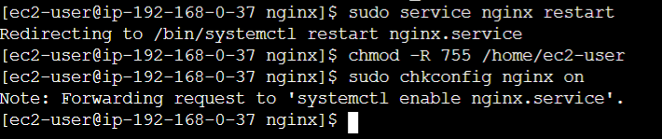

To check the output of the App, we can check using the Web-Tier-Instance public IP.

Edit the inbound rule of the web-tier instance

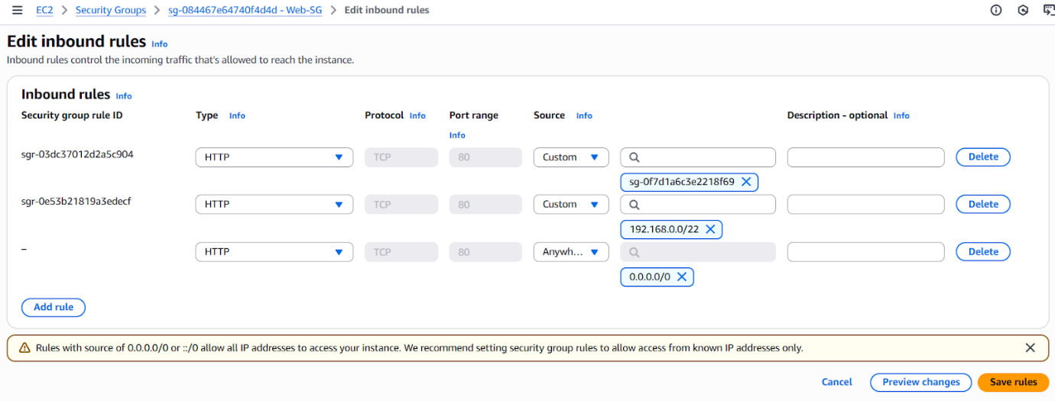

### Step 9: Final Testing

* Access frontend using Web Tier’s public IP
* Try inserting data into the app

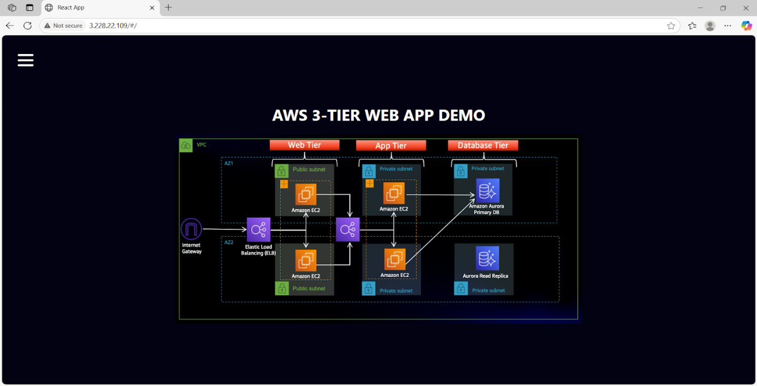

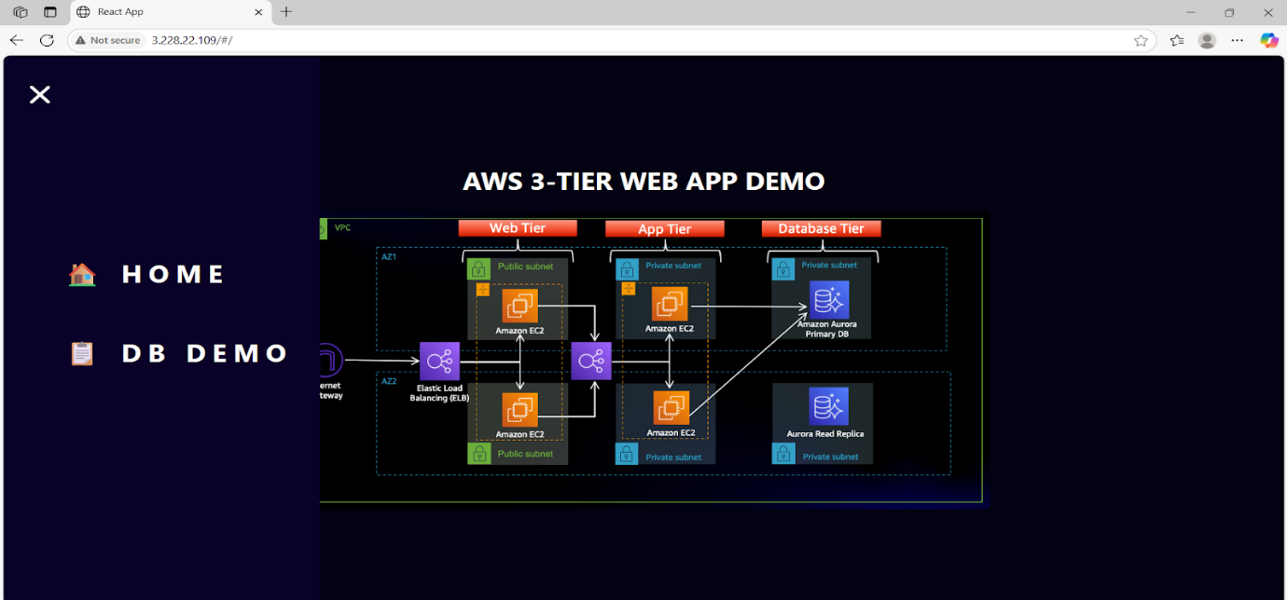

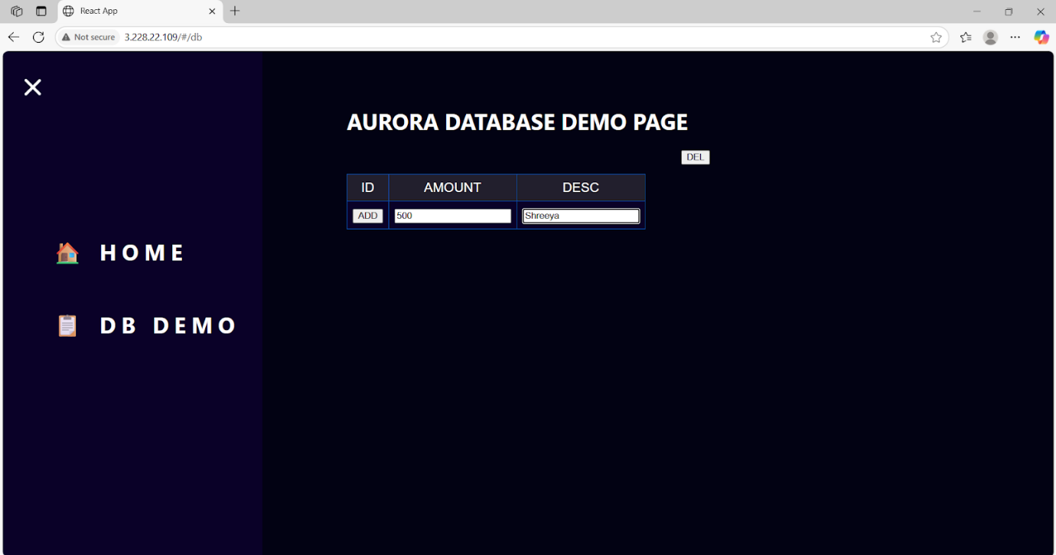

## 5. Security & Best Practices

* RDS in private subnet
* IAM role instead of access keys
* Security groups scoped to specific ports and IPs
* No hardcoded credentials in code

## 6. Challenges Faced

* Internal communication between tiers
* RDS subnet misconfiguration initially
* PM2 logs not retained until pm2 save was used

## 7. Conclusion

This project showcases the deployment of a modular, secure, and scalable 3-tier architecture on AWS using real-world services. Each component is isolated and independently deployable, ensuring maintainability and security.